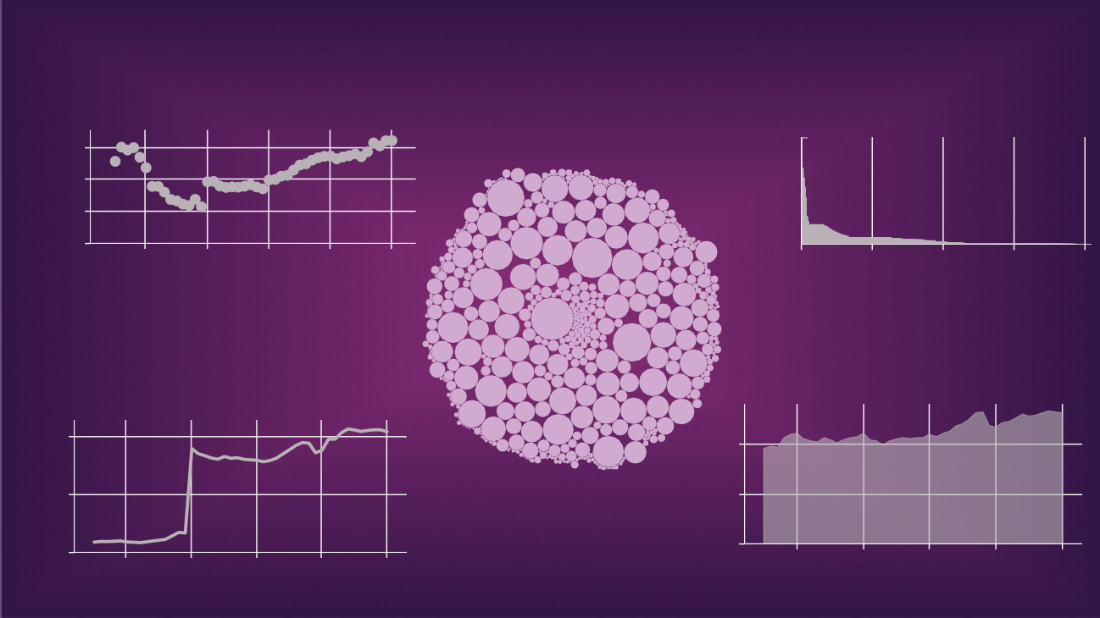

A GLOBAL CO2 EMISSION ANALYSIS

Cumulative ..

1500

1000

500

0

1980 1990

2000

Year

2010 2020

0B

2B

4B

Population

6B 8B

0

1000

20

500

10

0

0

1980 1990

2000

Year

2010

2020

1980 1990

2000

Year

2010 2020

Other Industry Co2

Flaring Co2

Sum of Cement Co2 P..